**Navigating the GenAI Frontier: Transformers, GPT**

**and the Path to Accelerated Innovation**

**Evolution of AI in Language Understanding:**

The progression from Deep Neural Networks (DNNs) and Long Short-Term Memory (LSTM) networks to transformers like BERT and GPT models represents a significant advancement in AI's ability to understand and generate human language. This journey reflects the continuous efforts to develop more efficient and effective natural language processing (NLP) models.

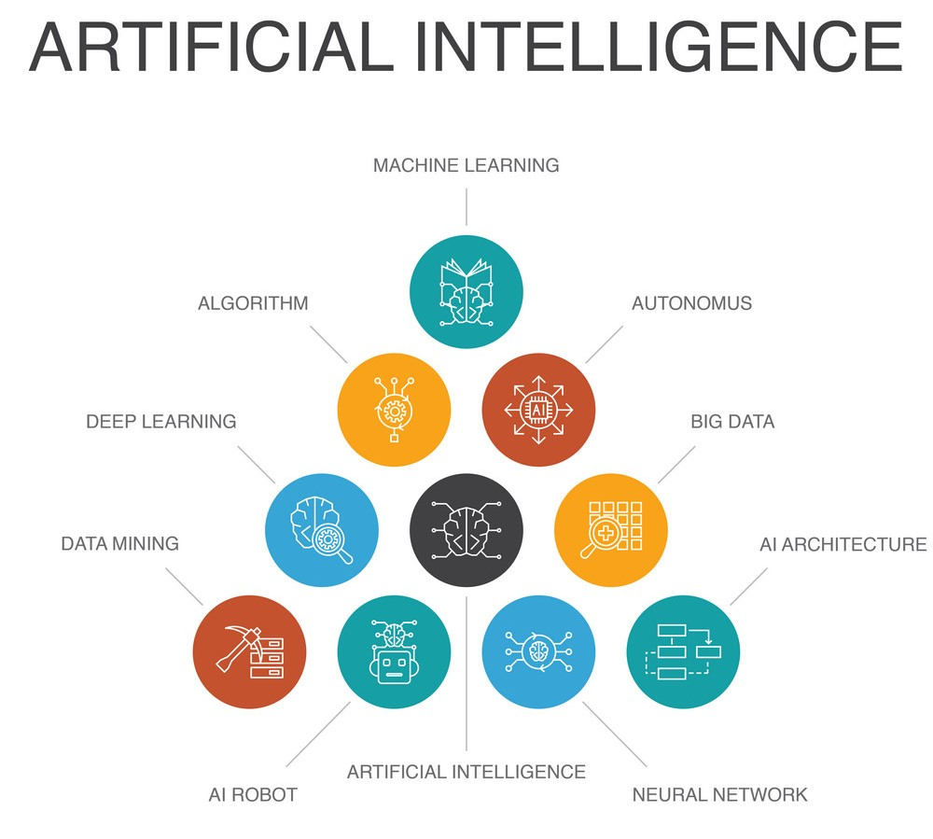

**Seq2Seq:**

**Authors:** Ilya Sutskever, Oriol Vinyals, Quoc V. Le

**Paper Title:** Sequence to Sequence Learning with Neural Networks (2014)

**Introduction of Seq2Seq Learning:**

The concept of "Sequence to Sequence Learning with Neural Networks" introduced the Encoder-Decoder architecture, specifically tailored for sequence-to-sequence (seq2seq) tasks such as machine translation. This architecture revolutionized the field by allowing for the seamless translation of sequences from one domain to another.

**NMT by Joint Learning to Align & Translate:**

**Authors:** Dzmitry Bahdanau, Kyunghyun Cho, Yoshua Bengio

**Summary:**

The introduction of attention mechanisms within the Seq2Seq framework by Bahdanau et al. marked a paradigm shift in neural machine translation. By dynamically focusing on different parts of the input sequence, the attention mechanism significantly improved translation quality, especially for long sentences and languages with varying word

**Revolutionizing Machine Translation:**

Both papers significantly enhanced translation quality, making machine translation more accurate and context-aware.

**Addressing Long-range Dependencies:**

The attention mechanism enabled models to capture long-range dependencies effectively, improving translation fluency. Enabling Context-awareness: Context-aware translation became achievable through the attention mechanism, enhancing overall translation coherence.

**Foundation for Further Innovations:**

The Seq2Seq model and attention mechanisms served as the foundation for subsequent advancements in NLP, driving progress in language understanding, generation, and dialogue systems. Impact on Research and Industry: These contributions have become indispensable tools in NLP research and industry applications, greatly improving system performance and capabilities.

**TRANSFORMERS**

Transformers represent a breakthrough in natural language processing (NLP) and sequential data modelling. Unlike traditional architectures like recurrent neural networks (RNNs) and convolutional neural networks (CNNs), transformers rely on a self-attention mechanism, enabling them to capture long-range dependencies and contextual information more effectively. Introduced in the landmark paper "Attention is All You Need," transformers have revolutionized various NLP tasks, including machine translation, text summarization, and language generation. Their ability to process input data in parallel and scale efficiently to handle large datasets has made them indispensable in modern AI applications.

**Self-Attention Mechanism:**

This mechanism allows the model to weigh the importance of each word in the input sequence concerning every other word, capturing long-range dependencies effectively.

**Encoder:**

The encoder module processes the input sequence and generates a series of hidden representations using multiple layers of self-attention and feed-forward neural networks.

**Decoder:**

The decoder module takes the encoder's output and generates the output sequence by attending to relevant parts of the input sequence and previously generated tokens.

**Positional Encoding:**

Positional encoding is added to the input embeddings to provide information about the position of each token in the sequence, enabling the model to understand the sequential order of the input.

**Feed-Forward Neural Networks:**

These networks are employed within each layer of the encoder and decoder to process the intermediate representations and generate the final output.

**Residual Connections and Layer Normalization:**

Residual connections facilitate the flow of information through the network, while layer normalization helps stabilize the training process by normalizing the activations within each layer.

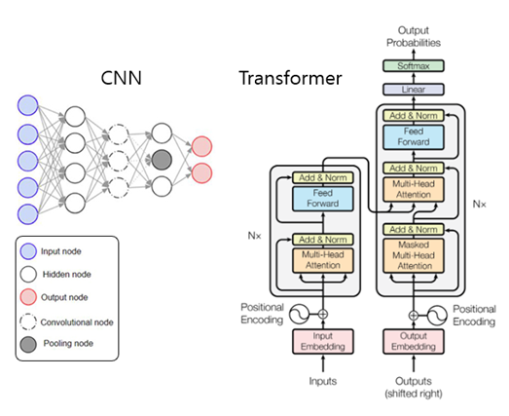

**Importance of Transformers**

The Transformer architecture has become a cornerstone in natural language processing (NLP) and has revolutionized various tasks in the field. Here are some key reasons why Transformers are important:

**Parallelization:**

Transformers allow for parallel processing of input sequences, unlike recurrent neural networks (RNNs) which process sequences sequentially. This parallelization significantly speeds up training and inference, making Transformers more efficient for processing long sequences and handling large-scale datasets

**Scalability:**

Transformers can handle input sequences of variable lengths without the need for padding, making them more versatile for a wide range of tasks. Additionally, Transformers can be scaled to larger models with more parameters, allowing for better performance on complex NLP tasks.

**Transfer Learning:**

Pre-trained Transformer models, such as BERT (Bidirectional Encoder Representations from Transformers) and GPT (Generative Pre-trained Transformer), have been pre-trained on large corpora of text data. These models capture rich linguistic representations that can be fine-tuned on downstream tasks with relatively little labelled data, making them highly effective for transfer learning in NLP

**Enhanced Performance:**

Transformers have demonstrated superior performance compared to traditional architectures like recurrent neural networks (RNNs) and convolutional neural networks (CNNs) across a wide range of NLP tasks, including machine translation, text summarization, and language generation.

Overall, the transformers have revolutionized the field of NLP and sequential data modelling, enabling breakthroughs in various applications and driving advancements in artificial intelligence.

**BERT**

BERT (Bidirectional Encoder Representations from Transformers) is a revolutionary language representation model introduced by researchers at Google AI Language in 2018. It has had a profound impact on various natural language processing (NLP) tasks by pre-training deep bidirectional representations from large amounts of unlabelled text data and fine-tuning them for specific tasks.

**Pre-training Data:**

BERT is pre-trained on large corpora of text data, such as Wikipedia articles, web pages, and books. The model learns rich contextual representations of words and phrases from the unlabelled text, capturing semantic and syntactic information.

**Fine-tuning:**

After pre-training, BERT's parameters can be fine-tuned on downstream NLP tasks, such as text classification, named entity recognition, question answering, and sentiment analysis. Fine-tuning involves updating the model's parameters on labelled task-specific data to adapt its representations for the specific task.

**Open Source and Accessibility:**

BERT is open-sourced by Google, allowing researchers and developers worldwide to use and build upon its architecture. Its availability and accessibility have democratized advanced NLP techniques, enabling rapid progress and innovation in the field.

**State-of-the-art Performance:**

BERT has achieved state-of-the-art performance on various benchmark NLP tasks, including question answering, sentiment analysis, and named entity recognition. Its effectiveness across a wide range of tasks highlights its robustness and applicability in real-world scenarios.

Overall, BERT's impact on NLP research and applications is profound, paving the way for enhanced language understanding and communication between machines and humans.

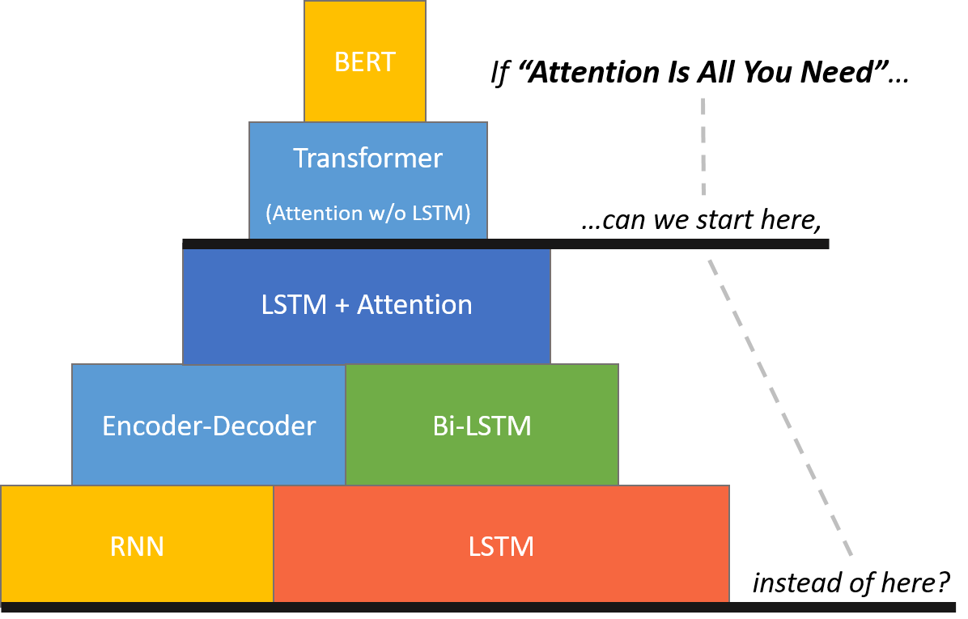

**LSTM**

Long Short-Term Memory (LSTM) networks are a type of recurrent neural network (RNN) architecture designed to overcome the limitations of traditional RNNs in capturing long-range dependencies in sequential data. Introduced by Hochreiter and Schmidhuber in 1997, LSTMs have become a cornerstone in deep learning, particularly for tasks involving sequential data, such as natural language processing, time series analysis, and speech recognition.

**Modelling Long-Term Dependencies:**

Traditional recurrent neural networks (RNNs) struggle with capturing long-range dependencies due to the vanishing gradient problem, where gradients diminish over time. LSTMs address this issue by introducing memory cells and gating mechanisms, allowing them to retain and propagate relevant information over long sequences.

**State-of-the-Art Performance:**

LSTMs have achieved state-of-the-art performance in numerous tasks, including language modelling, machine translation, sentiment analysis, and speech recognition. Their ability to capture complex patterns and dependencies within sequential data contributes to their superior performance.

**Model Configuration:**

In our model, we leverage the power of LSTM by incorporating two separate LSTM layers: one dedicated to processing input sequences and the other responsible for generating output sequences. This architecture is structured within a deep neural network framework consisting of four layers, allowing for sophisticated modelling of sequential data.

Overall, LSTMs have become a fundamental tool in deep learning, enabling the effective modelling of sequential data and driving advancements in various fields of artificial intelligence.

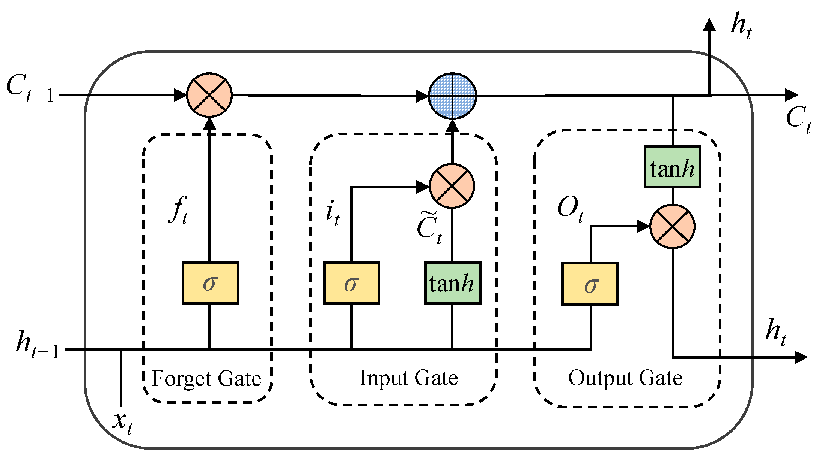

**CONCLUSIONS**

**Evolution of AI in Language Understanding:**

The evolution of AI in language understanding has led to transformative advancements, from traditional methods to deep learning techniques, revolutionizing natural language processing and shaping the future of human-computer interaction.

**Introduction to Sequence-to-Sequence Learning:**

Encoder-Decoder architecture enables seamless translation across domains.

**Importance of Transformers:**

Transformers are pivotal in natural language processing due to their ability to capture long-range dependencies, scale effectively, facilitate transfer learning, and achieve state-of-the-art performance across various tasks, driving advancements in language understanding and enabling more efficient NLP systems.

**Impact of BERT:**

BERT has significantly influenced NLP research by showcasing state-of-the-art performance and inspiring innovation in various tasks, setting new benchmarks and driving advancements in language understanding and model development.

**Limitations of DNNs:**

DNNs encounter limitations with fixed-dimensional inputs and targets, restricting their flexibility and adaptability to varying data types and structures.

**Role of LSTM Architectures:**

LSTM architectures play a pivotal role in effectively handling variable-length sequences and capturing complex patterns in sequential data, making them invaluable for tasks like natural language processing and time series analysis.

**Impact on Machine Communication:**

The adoption of advanced models enhances machines' language comprehension and generation, facilitating smoother human-machine interactions and advancing the capabilities of artificial intelligence in communication tasks.